**Week 6 Early Republic (2) and Rome’s Expansion**

**Outline**

1. Often it is claimed that the most important political development in 5th and 4th century BC Rome was the so-called “**struggle of the orders**”, the conflict between patricians and plebeians; but this view needed to be adjusted somewhat[1]. Patrician order was probably only formed after the end of the kingdom; admission to it was perhaps only blocked from **the middle of the 5th century** onwards.
2. Important prerogatives of the patricians
3. In the early period of the Republic, until the passing of the *lex Ogulnia de auguribus et pontificibus* (the Ogulnian Law on *augures* and *pontifices*) in 300 BC the college of priests called the *augures* exclusively consisted of patricians, The *augures* were one of the **four** most important colleges of priests in the Roman state (the *pontifices* made up another important priesthood); one of their main tasks comprised the **interpretation of all kinds of *auspicia***: signs which, if declared unfavourable, could halt any kind of public business, such as people’s assemblies. Thus, the control of the *auspicia* became an important weapon in the hands of the patricians[2].
4. *auctoritas patrum*: consent given by the *patres* who were member of a council (the senate) to decisions made by the people’s assembly. These *patres*, i.e., members of the senate, were patricians. In 339, the *auctoritas patrum* was moved to the time prior to a law’s passage.
5. Evidence that existed for a struggle or conflict between patricians and plebeians
6. Tribunes of the plebs (sometimes called tribunes of the people) were established in 494.
7. Assembly of the plebs in 492: *concilium plebis (comitia plebis tributa*).
8. *Concilium plebis* allowed to elect magistrates without *imperium[3]* in 471: tribunes of the plebs (5) and aediles (1).
9. Number of tribunes of the plebs raised from 5 to 10 in 457.
10. 449: decrees of *plebs* have a force of law.
11. 445: a ban on marriage between patricians and plebeians was lifted.

We saw that much of the legislation to solve the struggle between patricians and plebeians was affected by legislation in the *comitia centuriata[4].*

1. 367: law proposed by **tribunes of the plebs** C. Licinius Stolo (cos. 364 or 361) and L. Sextius Sextinus Lateranus (cos. 366) that allowed plebeians into the college in charge of the Sibylline Books, i.e., the *decemviri sacris faciundis.*
2. 367: one of the consuls elected every year had to be a plebeian.
3. 337: **praetorship** open to plebeians.
4. 287: *lex Hortensia*: legal authority was granted to all plebiscites, i.e., decision of the *comitia plebis tributa*; senatorial consent was **not** needed.
5. Other developments in the 4th century: debt bondage (*nexum*) and legislation aimed at stopping it.
6. Constitutional developments: the creation of **curule aediles**.
7. Explanations for Rome’s successful expansion
8. Army: manipular army.
9. Incorporation of former enemies into a larger political and constitutional framework.
10. *Ius Latii* (**Latin rights**), e.g., on colonies.
11. *civitas sine suffragio* (**citizenship without the vote**).
12. Alliances with Italian communities, who then became allies (*socii*).
13. Colonization: Roman and Latin colonies.

**Plebeians and patricians**

1. An important prerogative of the patricians: *auspicia*
2. Taking of the auspices (Livy, 6.41.6).
3. An important prerogative of the patricians was their monopoly on the *auspicia* (at least in the **early period** of the Republic), the observation of divine sign[5] and their interpretation (divination). The declaration of **adverse signs** could end official meetings (e.g., of the people’s assemblies).[6]
4. This right can be understood as something like a veto, a way to cancel voting and people’s assembly. Until the late Republic, the monopoly still exist.
5. *Auctoritas patrum* (authorization (授权，许可) of the **fathers**)
6. whether these *patres* were all the patricians, only those patricians **who had been magistrates**, or those who had served on the **council (senate)** is unknown. The important element was that through this measure the *patres* approved decisions made by the people’s assembly. This lasted until 339 when the *auctoritas patrum* was set **prior** to the vote in the people’s assembly[7].
7. Patricians’ dominance
8. The traditional view also wants to make us believe that the plebeians sought protection of their rights almost immediately after the abolition of the kingship.
9. But the earliest evidence is a section of the Twelve Table laws promulgated in 452-450 BC in which **marriages between patricians and plebeians were forbidden**: “Those who belong to the Senatorial Order and are styled Fathers, shall **not** contract marriage with plebeians (Cic., *de rep*., 2, 37, 63)” (*Twelve Tables* tab. 11.2)[8].
10. Evidence for a struggle or conflict between the two parties
11. **Tribunes of the people**
12. The plebeians used **tribunes of the people**. The rights were established in 494 by a law (*lex sacrata*, i.e., sacred law) by the *comitia centuriata*.
13. Rights of the tribunes

* *Sacrosanctitas* (violence or murder of a people’s tribune was penalized by a curse).
* Right to intercede on behalf of an **individual citizen** who made an appeal (上诉) to the Roman people against the action of a magistrate (*auxilium[9]*).
* Veto against actions taken by other magistrates (right of interceding: *intercessio*).

1. 492: *lex Icilia de tribunicia potestate*

The law was passed by the *comitia centuriata* granting tribunes of the people the right to convene (召开) an assembly called ***concilium plebis[10]***(***comitia plebis tributa***).

1. 471: *lex Publilia Voleronis de plebeis magistratibus*

The law was passed to allow the *concilium plebis* to elect magistrates **without** *imperium* (tribunes of the people and aediles[11]—these latter magistrates were initially **subordinate to the tribunes** and supervised the temple and cult of **Ceres** and **Diana** on the Aventine): 5 tribunes were to be elected[12]. The tribe (*tribus*) became the voting unit.

1. 457: a law was passed **raising the number of tribunes** of the people annually elected from 5 to 10.

**Other political developments in the 5th century BC**

1. Decemvirate[13] (452-449)

A board of 10 magistrates was elected in these years to provide Rome with a new law code; this code is known as the *Law of the Twelve Tables*. The *decemviri* began to behave in a tyrannical fashion in 449 and were, according to tradition, expelled by a popular revolution.

1. 449 BC: several laws were passed as a reaction against the *Law of the Twelve Tables*.
2. Election of consuls to replace the *decemviri*.
3. Ban on the creation of magistrates **without** *provocatio* (right of citizens “to appeal to the Roman people against the exercise of a magistrate’s power of physical coercion”). Appeals could end up before the *comitia centuriata* (in case of impending capital punishment) or the *comitia tributa* (in case of a fine).[14]
4. Amnesty for citizens who had **refused to serve in the army** in the previous year.
5. These 3 laws were passed **in the assembly headed by a people’s tribune**.
6. 4 important related laws were passed by the ***comitia centuriata***in 449:
7. Decrees of the plebs have the force of law.
8. Another later related law was passed:

*lex Hortensia* (287) establishing that all plebiscites had the force of law for **all citizens**, including patricians. The textbook also mentions a law from 339, but its contents are disputed.

1. No magistrates were to be created without provocatio.
2. A law confirming the *sacrosanctitas* of the people’s tribunes.
3. A law concerning the storage of senatorial decrees confirming that there was a formal advisory body by this date, the *senatus[15]* (senate). The exact constitution of this advisory body is unknown; it emerged from the *patres* who served on an advisory council of the king during the regal period. The *lex Ovinia* passed sometime between 318 and 312 arranged for the censors to **draw up a list of Roman citizens**[16].
4. Further laws were passed between 445 and 440
5. 445: ban on marriage between patricians and plebeians was **lifted**.

444: replacement of 2 chief magistrates by a college of 4 (or more) military tribunes with consular authority.

443: the creation of censors.

440: the creation of a prefect of the **grain supply**.

1. The last three laws show that the demands of the government **exceeded** what could be delivered by the existing magistracies.
2. Laws and relations between patricians and plebeians

It is striking that much of the reforms to solve the struggle between patricians and plebeians was affected by legislation passed in the *comitia centuriata*. These laws do not give evidence for **much strife** between patricians and plebeians.

**Problems and developments in the 4th centuries BC**

1. 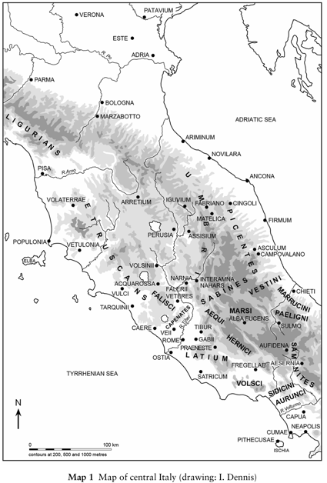First of all, in needs to be pointed out that another important element in our evidentiary basis for this period comprises **legislation**, especially that of the year 367. It is indicative of some of the problems that Roman society was facing.
2. By 367 Rome had expanded beyond the confines of the city and conquered southern Etruria (including the Etruscan city of Veii) and also the territory of the Volsci.
3. Increase in territory led to an increase in wealth that was **unevenly distributed**; subsistence farmers encountered problems in years of bad crop yields; to solve the financial distress in the short-term subsistence farmers could **borrow money at high interest rates**; if the debt could not be repaid, a farmer could become a *nexus*, a status that required him to work for his creditor until the loan and interest were paid off. The creditor was allowed to keep the debtor **in chains[17]**.
4. Increase in the number of **citizens**, probably from c. 100,000 to 150,000[18] in the period roughly from 450 to 350 BC. The causes of this increase are likely to be immigration and the **manumission of slaves**.
5. Increase in the number of **wealthy plebeian families** who resented the patrician monopoly of the magistracies after 450 BC.
6. What measures were taken to address the problems that emerged in the first half of the fourth century BC?
7. Important is the legislative programm initiated by **tribunes** of the plebs C. Licinius Stolo (cos. 364 or 361) and L. Sextius Sextinus Lateranus (cos. 366) in 367[19] in the *comitia plebis tributa* (so-called *Leges Liciniae Sextiae*).

* Interest paid on debts deducted from the principal amount of the debt; debts can be repaid in three equal installments.[20]
* Law limiting the amount of **public land** (*ager publicus*) that anyone could control to 500 *iugera*. *Ager publicus* pertains to land that belongs to the Roman state[21]; it could be **leased** to individuals who paid a rent, called a *vectigal[22]*.
* Law stipulating that **at least** one consul in each year had to be a plebeian; military tribunes of consular authority were **no longer elected**; it is possible that **only from (around) this year**, Rome’s two chief magistrates were called consuls.
* law that increased the college in charge of the Sibylline Books from 2 to 10, and stipulated that the *decemviri sacris faciundis* had to consist equally of patricians and plebeians. The Sibylline Books were a collection of prophetic sayings claimed to be compiled by a prophetess from the area around the Bay of Naples. The books were **consulted in times of emergency[23]**. The priests attached to this college had to provide ritual and sacrificial responses to problems[24].

1. These two tribunes of the plebs probably also sponsored a law that instituted the praetorship to take over the **civil jurisdiction** from the consuls; initially the office was held by patricians; it was opened up to plebeians in 337; in 242 a **second** praetor was added to deal with civil matters **between foreigners (*peregrini*) and Roman citizens (*cives Romani*)**. The praetor’s *imperium* was **inferior** to that of the consul[25].
2. Possibly also a law was passed in this year or around this period that created the office of **curule** (行政的) *aedilis*, a patrician equivalent to the already existing **plebeian** *aedilis*. Curule and plebeian aediles were now to be elected in **alternating years**.
3. The plebeian aediles had been elected, like the tribunes of the plebs, by the *comitia plebis tributa* (*concilium plebis*). The curule aediles were elected by the *comitia tributa* that also included patricians: *comitia populi tributa*. When the latter people’s assembly exactly came into existence is unknown, but at least by this time.

|  |  |  |  |  |
| --- | --- | --- | --- | --- |
|  | ***Curiata*** | ***Centuriata*** | ***Tributa populi*** | ***Tributa plebis*** |
| **Composition** | 30 lictors, 1 to represent each *curia* | All citizens | All citizens | All plebeians |
| **Meeting place** | *Comitium* | Campus Martius | Forum or Capitol, except for elections (Campus Martius) | As for *tributa populi* |
| **Structure** | 30 *curiae*, 10 from each of 3 ancient tribes | 193 centuries, of which 18 *equites*, 170 *pedites*, 5 unarmed | 35 tribes, 4 urban, 31 rural | As for *tributa populi* |
| **Presiding officer** | Consul, praetor, *pontifex maximus* | Consul, praetor, dictator, *interrex* | Consul, praetor | Tribune of the plebs or aedile of the plebs |
| **Elections** | None | Consuls, praetors, censors | Curule aediles, quaestors | Tribunes, aediles of the plebs |
| **Legislation** | (under consul) confirm *imperium*; (under p.m.) wills, adoptions, etc. | Not normal after 218, except to declare war | Normal in late Republic | Laws (*plebiscita*) proposed by tribunes |
| **Judicial functions** | None | Capital charges, but rare in 1st century | Serious charges, but later replaced by courts | As for *tributa* *popul*i, but involving the tribunes |

1. Further developments until 287 BC
2. Legislation concerning the problem of **debt** in 357, 347, 326 BC. In the last year, the *lex Poetelia Papiria* had been passed; it **forbade** debtors to be imprisoned by creditors, which operated as a kind of enslavement.
3. A law was passed in 342 BC banning the iteration of the **same office** **within 10 years**; i.e., it stipulated a 10-year interval between holding the same office; it also banned the holding of multiple offices **simultaneously**; it also explicitly permitted both consuls to be plebeians.
4. 339: several laws were passed.

* Binding authority was granted to plebiscites, i.e., laws passed by the *comitia plebis tributa*.
* *Auctoritas patrum*: consent of the senate to bills proposed to the people’s assemblies was moved to the time **prior** to a law’s passage.
* One of the censors had to be a plebeian.

1. 287: *lex Hortensia*
2. Legal authority was granted to all plebiscites, i.e., decisions of the *comitia plebis tributa*; senatorial consent was **not** needed.
3. After the *lex Hortensia* the distinction between patricians and plebeians did **not matter so much** anymore in access to offices. The more important distinction now became whether one had held office or not. What increasingly more mattered was whether one a member of the *nobiles* or not. The *nobiles* (plural) comprised members of Rome’s elite families who at some point in their history **had held the consulship[26]**.

**Foundation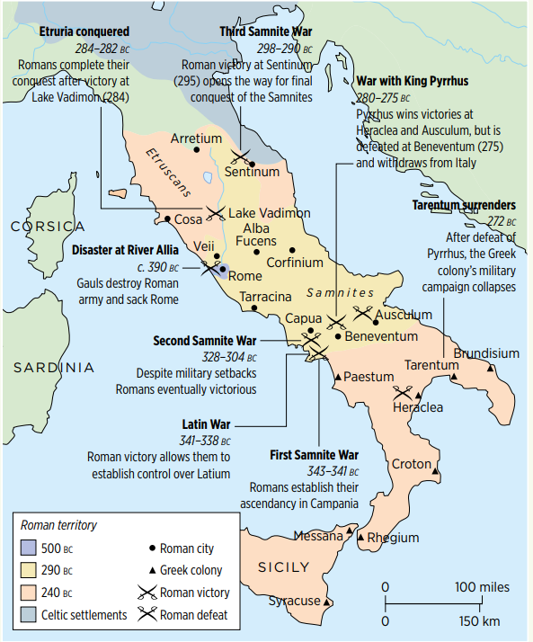 of Rome’s expansion**

The other major development of 4th century that continued in the centuries afterward was Rome’s expansion. By what means did Rome manage to expand and create a Mediterranean empire? In a nutshell, Rome’s success not only depended on its army, but also to incorporate former enemies into a larger political and constitutional framework.

1. Incorporation of Latin
2. *Foedus Cassianum* (**Cassian treaty** of 493 BC): in 499 or 496, a war broke out between the Latin League and Rome in which the latter emerged as victor at the Battle of Lake Regillus. In 493, a treaty was concluded between Rome and the Latin states by Spurius Cassius Vecellinus (cos. 502, 486).
3. Evidence

Cicero, *In Defence of Balbus*, 53 (56 BC):

“Who does not know that a treaty was struck with all the Latins in the consulship of Spurius Cassius and Postumus Cominius, which not so long ago we remember was engraved and written out upon a column of bronze standing behind the Rostra?”

The same information is given by Livy, 2.33.4, 9.

1. The terms of the treaty are given by Dionysius of Halicarnassus, 6.95.

“At the same time, a new treaty of peace and friendship was made with all the Latin cities, and confirmed by oaths, inasmuch (因为) as they had not attempted to create any disturbance during the sedition (煽动叛乱), had openly rejoiced (欢庆) at the return of the populace, and seemed to have been prompt in assisting the Romans against those who had revolted from them. The provisions of the treaty were as follows:

* Let there be **peace** between the Romans and all the Latin cities as long as the heavens and the earth shall remain where they are.
* **Let them neither make war** upon one another themselves nor bring in foreign enemies nor grant a safe passage to those who shall make war upon either.
* **Let them assist one another**, when warred upon, with all their forces, and
* let each have an **equal share of the spoils and booty** taken in their common wars.
* Let suits relating to private contracts be determined within ten days, and in the nation where the contract was made.
* And let it not be permitted to add anything to, or take anything away from these treaties except by the consent both of the Romans and of all the Latins.

This was the treaty entered into by the Romans and the Latins and confirmed by their oaths sworn over the sacrificial victims.”

1. *Fides*

The underlying principle in this this—but also other treaties—is *fides* (good faith) that is guaranteed by oaths sworn before the gods.

1. The conclusion of treaties seems to have depended (at least in the early history of Rome) on a procedure that involved **a college of priests** called the *Fetiales*. Livy (1.24.4-9) provides us with the most elaborate account of this procedure—albeit in the context of a treaty between the Romans and the Albans in the 7th century BC:

Before proceeding with the battle, a treaty was made between the Romans and the Albans, providing that the nation whose citizens should triumph in this contest should hold undisputed sway (控制权) over the other nation. One treaty differs from another in its terms, but **the same procedure is always employed**. On the present occasion we are told that they did as follows, nor has tradition preserved the memory of any more ancient compact. The *fetial* asked King Tullius, “Dost thou command me, King, to make a treaty with the *pater patratus* of the Alban People?” Being so commanded by the king, he said, “I demand of thee, King, the sacred herb.” The king replied, “Thou shalt take it untainted.”

The *fetial* brought from the citadel (城堡) an untainted plant. After this he asked the king, “Dost thou grant me, King, with my emblems (徽章) and my companions, the royal sanction, to speak for the Roman People of the Quirites?” The king made answer, “So far as may be without prejudice to myself and the Roman People of the Quirites, I grant it.” The *fetial* was Marcus Valerius; he made Spurius Fusius *pater patratus*, touching his head and hair with the sacred sprig. The *pater patratus* is appointed to pronounce the oath, that is, to solemnize the pact (庄严地缔结条约); and this he accomplishes with many words, expressed in a long metrical (韵文的) formula which it is not worthwhile to quote. The conditions being then recited, he cries, “Hear, Jupiter; hear, *pater patratus* of the Alban People: hear ye, People of Alba: From these terms, as they have been publicly rehearsed from beginning to end, without fraud, from these tablets, or this wax, and as they have been this day clearly understood, the Roman People will not be the first to depart. If it shall first depart from them, by general consent (同意), with malice aforethought (蓄意而为), then on that day do thou, great Diespiter, so smite the Roman People as I shall here to-day smite this pig: and so much the harder smite them as thy power and thy strength are greater.” When Spurius had said these words, he struck the pig with a flint (燧石). In like manner the Albans pronounced their own forms and their own oath, by the mouth of their own **dictator** and priests.

1. Scholars have cast doubt on the accuracy of this procedure, but on the basis of other evidence which provides similar evidence, it seems to have been employed, according to John Rich maybe **until the imperial period**. John Rich, *“The Fetiales and Roman international relations”*,in: James H. Richardson and Federico Santangelo (eds), *Priests and State in the Roman World* (Stuttgart: Franz Steiner, 2011) 187-242.
2. At any rate, the effect of this treaty between Rome and the Latins was that the army would henceforth consist of Roman citizens and Latins.
3. In 486, the Hernici, a **non-Latin** people, entered the alliance. This addition provided a Rome with a model for creating similar agreements with other non-Latin nations.
4. Latin rights (the *ius Latii*)
5. Right of *commercium*: involved the privilege to have contractual business relations with the Romans.
6. Right of *conubium*: right to marry Roman citizens.
7. Right to move to Rome.
8. The relations between Rome and the Latin League soured, and broke down in 341.
9. In 338 BC Rome emerged as victor and created separate bilateral arrangements **with each of the Latin towns**.
10. In the years afterwards, as Rome expanded, it also began to confer a new type of Roman citizenship on some of Italy’s communities: *civitas sine suffragio* (citizenship without the vote).

* Payment of taxes.
* Liable to service in the army (*dilectus*)
* Rights of Romans, but no voting rights.

1. Colonization: establishment of Roman and Latin colonies in Italy.[27]
2. 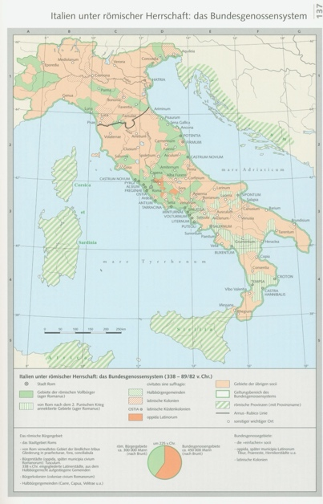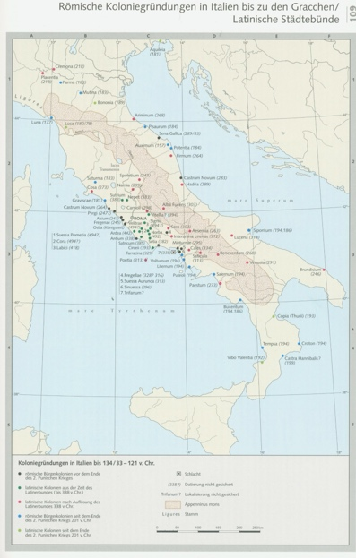Conclusion of alliances with Italian communities (allies, *socii*)on whom **none** of the abovementioned arrangements were conferred. The *socii* served in the army, as did the Latins. All these measures allowed Rome’s pool of manpower to be enlarged.
3. New army structure based on maniples (units of roughly 120 men).
4. The early Roman army consisted of **infantry soldiers** who fought like the Greek hoplites (armed with swords, spears, round shields, cuirass (胸甲), greaves (护腿板), and helmets) in a phalanx (方阵).
5. This structure underwent **gradual** changes in the 4th and early 3rd centuries BC.
6. Sub-units consisting of smaller numbers of men were created in the phalanx-legion: these sub-units were called maniples (*manipuli*: “handfuls”) and were capable of a certain amount of **independent action[28]**.
7. The round shield was replaced by the oval Italic shield, the *scutum*.
8. The thrusting spear was discarded for a throwing javelin (标枪) by most soldiers (**not all**) by the early years of the 3rd century BC at the latest.
9. The **legion** was the largest unit of the Roman army, consisting of c. **4200** men, but the exact size in the 4th century is **not known[29]**. A legion would be **commanded** **by a consul (sometimes praetor)[30]**. In addition, each legion had 6 military tribunes (who were *equites*, i.e., belonging to the equestrian class)[31].
10. Structure of a legion in the **middle Republic**

* Line of light-armed men, the *velites*: a sword, javelins and a small circular shield *(parma*)*—*1200 men.
* 10 maniples of *hastati* (spearmen): *scutum*, short Spanish sword (*gladius*), and two *pila* (singular *pilum*; throwing spear); earlier (c. the 4th century BC) on they had a *hasta* (short thrusting spear)—1200 men.
* Maniples of *principes* (chief men, strongest and tallest ones in the legion): *scutum*, short Spanish sword (*gladius*), and two *pila* (singular *pilum*; throwing spear); earlier on they had a *hasta* (short thrusting spear)—1200 men.
* Line of *triarii* (third-rank men)—the oldest and most mature soldiers: *scutum*, short Spanish sword *hasta* (short thrusting spear)—600 men.
* Each maniple had **two** *centurions* (centurions); the most senior among them held command. The centurion of the extreme right-hand maniple of the *triarii* was the *centurio primi pili* (later called the *primuspilus[32]*); he was included along with the military tribunes into the **general’s war-council**.
* All: bronze pectorals, bronze helmets, and greaves.
* Total: 4200 men; but in times of emergency 5000 men could be filled into a single legion.
* The best evidence is provided by Polybius[33] in book 6 of his *Histories*. The account in Livy, 8.8, appears not to have been altogether accurate; it is inserted into the narrative of 340 BC.
* 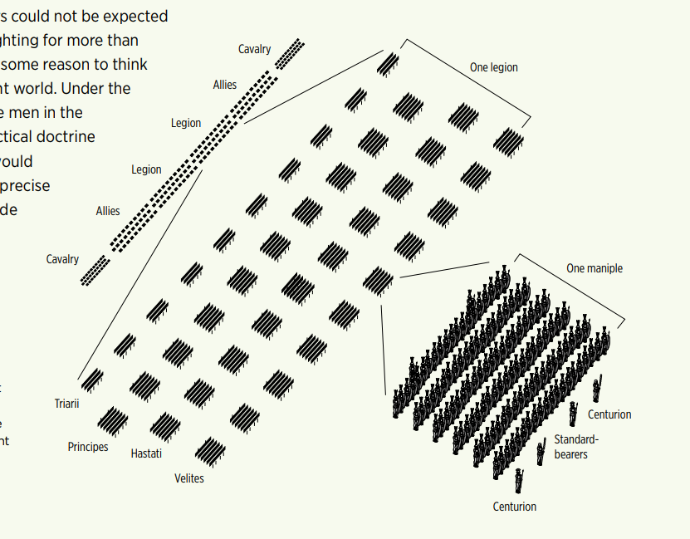The cavalry of a legion consisted of 300, divided into 10 *turmae* of 30 cavalries. Each *turma* had 3 *decuriones*; the senior decurion commanded the *turma.*

1. Sources of the legion: Livy, 42.34.5-11.

“‘I became a soldier in the consulship of P. Sulpicius and C. Aurelius (200 BC). In the army which was taken over to Macedonia I served two years in the ranks against **King Philip[34]**; in the third year because of my bravery T. Quinctius Flamininus[35] gave me a post as **centurion** in the tenth maniple of the *hastati*. After Philip's defeat, when we had been brought back to Italy and released, I immediately set out for Spain[36] as a volunteer with the consul M. Porcius[37] (195 BC). This commander judged me worthy to be assigned as centurion of the first century of the *hastati*. For the third time, I enlisted again as a volunteer in that army which was sent against the **Aetolians** and **King Antiochus[38]** (191 BC). By Manius Acilius[39] I was made centurion of the first century of the *principes*. When Antiochus had been driven out and the Aetolians subdued, we were brought back to Italy. And twice after that, I served in campaigns where the legions were in commission for a year. Then I campaigned twice in Spain (181 and 180 BC), first under Q. Fulvius Flaccus[40], and then under the **praetor** Ti. Sempronius Gracchus[41]. I was brought home by Flaccus along with the others whom he brought with him from the province to take part in his Triumph because of their bravery. Four times within a few years I held the rank of *primus pilus* (i.e., centurion of the first century of the *triarii*). Four and thirty times I was rewarded for bravery by my commanders. I have received six civic crowns[42]. I have served out twenty two years in the army and am more than fifty years old.’”

1. These innovations were the other pillar on which Rome’s expansion in the 3rd and 2nd centuries depended.

1. The conflict was not constant and not that fierce.
2. A sign of Theocracy.
3. *Imperium* in Ancient Rome denoted the authority granted to magistrates, enabling them to **command armies** and govern. Initially, this power was held by kings and later by **consuls** and **praetors** during the Republic. The *fasces* symbolized their authority. As Rome expanded, *imperium* extended to provincial governors, allowing them to **administer, judge, and lead militarily**. *Prorogatio* extended a magistrate's *imperium* beyond their term, leading to roles like proconsuls. Augustus centralized *imperium* within the emperor, creating *imperium maius*, marking the shift from a republic to an autocracy. *Imperium* was key to Rome’s governance and military control.
4. The classes were divided by properties; thus, this indicates that conflicts were between patricians and plebeians, not between the poor and the wealthy. In the late Republic, few differences between plebeians and patricians, while the gap between the *nobiles* and commons and the poor and the wealthy widened.
5. The Iliad narrates the events of the final year of the Trojan War, focusing on the wrath of Achilles, his withdrawal from battle, the death of his friend Patroclus, Achilles' revenge on Hector, and Hector's funeral, highlighting the heroism and tragedy of both Greek and Trojan warriors. The war saw frequent interventions by the gods, such as Athena, Apollo, and Hera, each supporting different factions and influencing the course of the conflict.
6. The textbook read that the *augures* were not monopolized by the patricians, and consuls could also serve as *augures*.
7. In the late Republic, *auctoritas patrum* was not necessary for passing a law.
8. This means that at that time, plebians are under the control of the patricians.
9. “help”
10. This assembly excluded the patricians. Its voting process is uncertain, which may be similar to *comitia tributa*.
11. 1 – 2 – 4.
12. 2 – 5.
13. “Decem” means 10.
14. (2) 禁止在没有上诉权（即公民“向罗马人民上诉反对某位官员行使身体强制权力的权利”）的情况下任命官员。上诉可能会提交到百人大会（*comitia centuriata*，适用于迫在眉睫的死刑案件）或部族大会（*comitia tributa*，适用于罚款案件）。
15. “old man”.
16. This event occurred every 4/5 years.
17. I.e., potential slavery and imprisonment of debtors. This was also a phenomenon in Greece, such as Athens.
18. The figures comes from Livy and are not accurate.
19. Around 367.
20. 债务所支付的利息从债务本金中扣除；债务可以分三期等额偿还。
21. The land was acquired mainly through conquer.
22. This income was important for the state until the late Republic.
23. E.g., during the 2nd Punic War.
24. E.g., to introduce a god from Asia Minor.
25. lictors: 6 v.s. 12.
26. M. Tullius Cicero did not belong to the *nobiles*, because he was the first man (*novus homo*) in his family to held the consulship.
27. Lasting until the 2nd century BC.
28. Maniple is a highly mobile unit. In the past, soldiers stood in a line with shields and swords, using one’s shield in the left hand to protect the one on his left.
29. It may consist of 6000 men.
30. 2 legions per magistrate.
31. The military tribune was a stepping stone for the sons of senators and former magistrates to held higher office.
32. “Most senior centurion”, always a plebeian.
33. The Greek historian had seen the army in war in his eyes.
34. Philip V (r. 221-179), defeated in the Second Macedonian War (200-197). 171: consuls were P. Licinius Crassus and C. Cassius Longinus; the latter of them was assigned Macedonia; beginning of the Third Macedonian War (171-168).
35. T. Quinctius Flamininus (cos. 198).
36. After the 2nd Punic war, Spain became a province.
37. M. Porcius Cato (cos. 195).
38. Roman-Seleucid War (192-188).
39. M. Acilius Glabrio (cos. 191).
40. Q. Fulvius Flaccus (praetor 182; propraetor 181; both years in Hispania Citerior; cos. 179).
41. Ti. Sempronius Gracchus (praetor 180 in Hispania Citerior).
42. Awarded to citizens who save other citizens’ lives.